Sandbank and Valley Nursery Schools Federation

Promoting British
Values
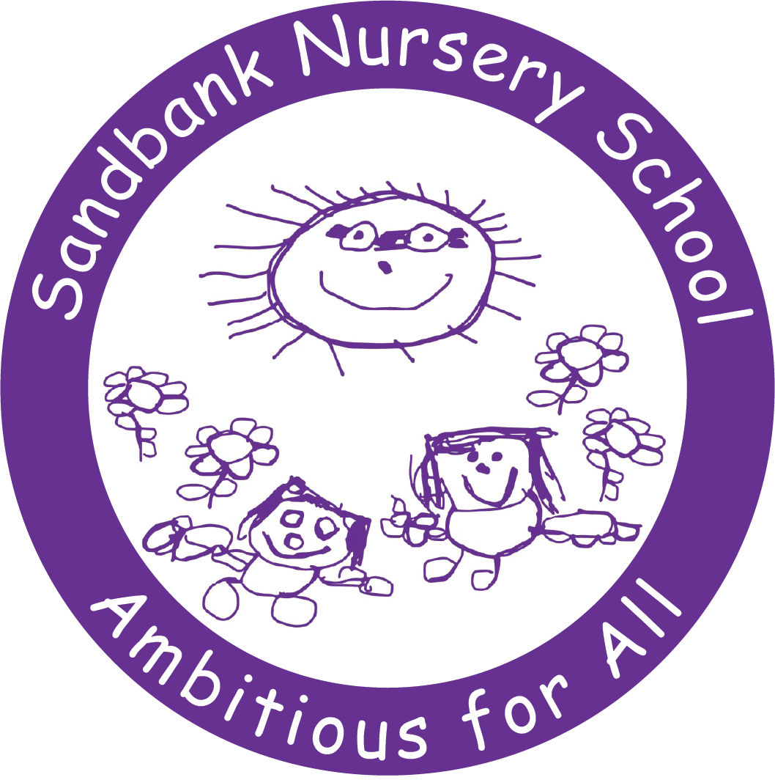

April 2023

Promoting British Values

Our school and governors have adopted the local authority policy on promoting British values in schools. It states:
“We encourage pupils to respect the fundamental British values of democracy, the rule of law, individual liberty and mutual respect, and tolerance of those with different faiths and beliefs. We ensure that partisan political views are not promoted in the teaching of any subject in the school and where political issues are brought to the attention of the pupils; reasonably practicable steps have been taken to offer a balanced presentation of opposing views to pupils”.
This is embedded in our school aims, specifically, we aim to:
- Develop respect, co-operation and positive relationships between children, staff, parents and the wider community
- Support parents and carers in their role as educator and value their contribution to lifelong learning for children and themselves
- Promote inclusivity
- Promote mutual trust and respect and celebrate equality and diversity
These elements of our aims are reflected in our school environment, our curriculum and in the positive ethos which exists in our school.

